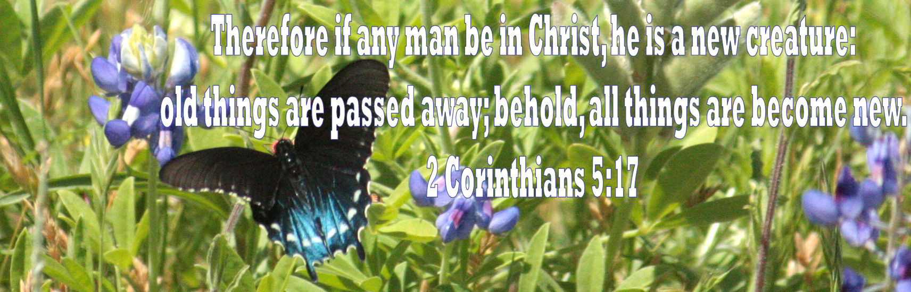
Please join Biblical Research and Teaching Ministry of Austin for
A Family Weekend in the Word at:
Camp Tejas
1038 PR 2191 Giddings, Tx 78942 (979) 366-2422
May 11-14
Friday 7:00pm – Monday 11:00am

Please join us in welcoming Rev. Gerald Wrenn to teach the Word of God concerning the theme of “New and Renewed in Christ.”

Along with some great teaching from the Bible, this will be a fun filled THREE DAY weekend to enjoy camp activities and to spend some great quality time with family. Plan ahead to have the extra day available to spend with the Family of God!

Registration is in full swing and will continue through April
Registration after November 12 (per Adult) is $252.00*
Registration after November 12 (age 3 through 14) $106.00** (Babies through age 2 are free)
Registration after November 12 (age 15 through 17) $252.00*

(The availability of children’s fellowship will be determined by need of the family and willingness of those who answer the call to serve)

This registration includes 3 nights lodging and 7 meals plus included Camp Activities

Send registration money by mail to:
George Logsdon, 15309 Fitzhugh Rd., Dripping Springs, TX 78620
(If sending a paper check in the mail, please put "New and Renewed" in the Memo Line.) OR:
Pay registration money via PayPal to: kriagel@aol.com.
(If paying via PayPal, please send as a gift with a note that says "for Gerald Wrenn weekend." )

Please fill out and return the Registration Form. You may mail this with your check or attach it to an email to kriagel@aol.com Call George or Kristen with any questions at 512-829-4811.

Anyone wishing to donate financial assistance can do so by check, cash or PayPal same as registration. Please make a note in the memo that money is meant to “assist others” or if you prefer, who you specifically wish to assist.

Anyone needing financial assistance please contact us to see if any is available!

This will be a fun weekend! We will have morning and evening teachings while the afternoons will be spent enjoying camp activities, games, fellowship, and lots of fun for the family.

